**Progress Report on AI-Driven Proactive Maintenance API Deployment**

# **Introduction**

This report's goal is to provide an overview of the developments made in the Flask deployment of the AI-Driven Proactive Maintenance API. This project aims to improve proactive maintenance techniques by offering a dependable way to forecast equipment failure based on IoT data.

# **Deployment Summary**

I successfully deployed the Flask application on PythonAnywhere. Below are the key steps taken during the deployment process:

**Account Creation**: Created a free account on PythonAnywhere.

**Web App Setup**:

* Navigated to the "Web" tab and added a new web app.
* Selected the Flask framework and specified the Python version.

**Code Upload**:

* Uploaded the app.py file and the random_forest_model.pkl model file.

**Configuration**:

* Ensured that the application was configured to run on the correct port and settings.

**Testing**:

* Verified the application was running by accessing the root URL, which displayed a welcome message.

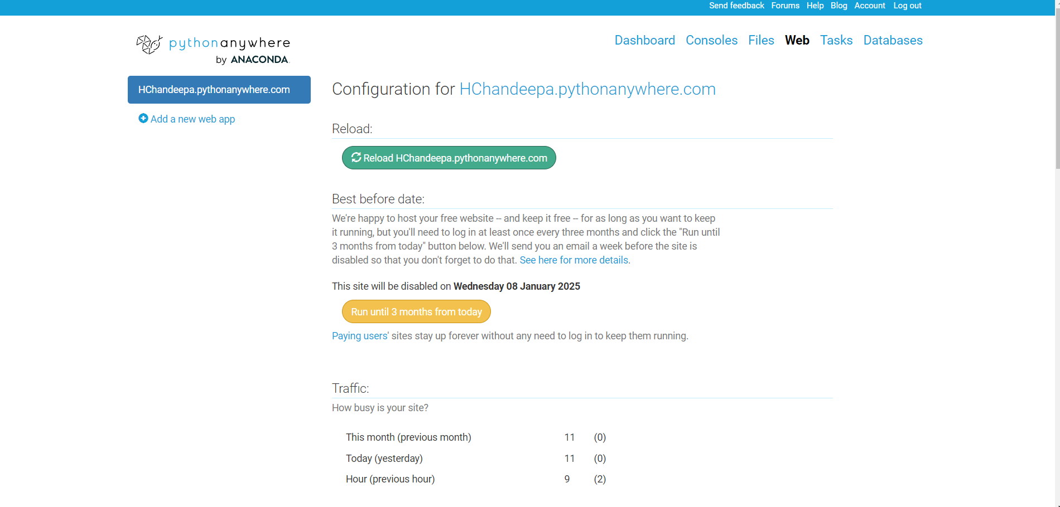

# **API Functionality**

The API provides an endpoint for making predictions regarding equipment failure based on the following features: Temperature, Humidity, and HVAC_Status.

**Endpoint Details**

* **Root Route**: GET /
  + - Returns a welcome message.
* **Prediction Route**: POST /predict
  + - **Input**: JSON format containing the features:

{

"Temperature": 72,

"Humidity": 50,

"HVAC_Status": 1

}

* **Response**: JSON indicating the risk of failure:

{

"failure_risk": 0 }

# **Testing**

The API has been tested successfully using Postman, which confirmed that it responds correctly to valid input.

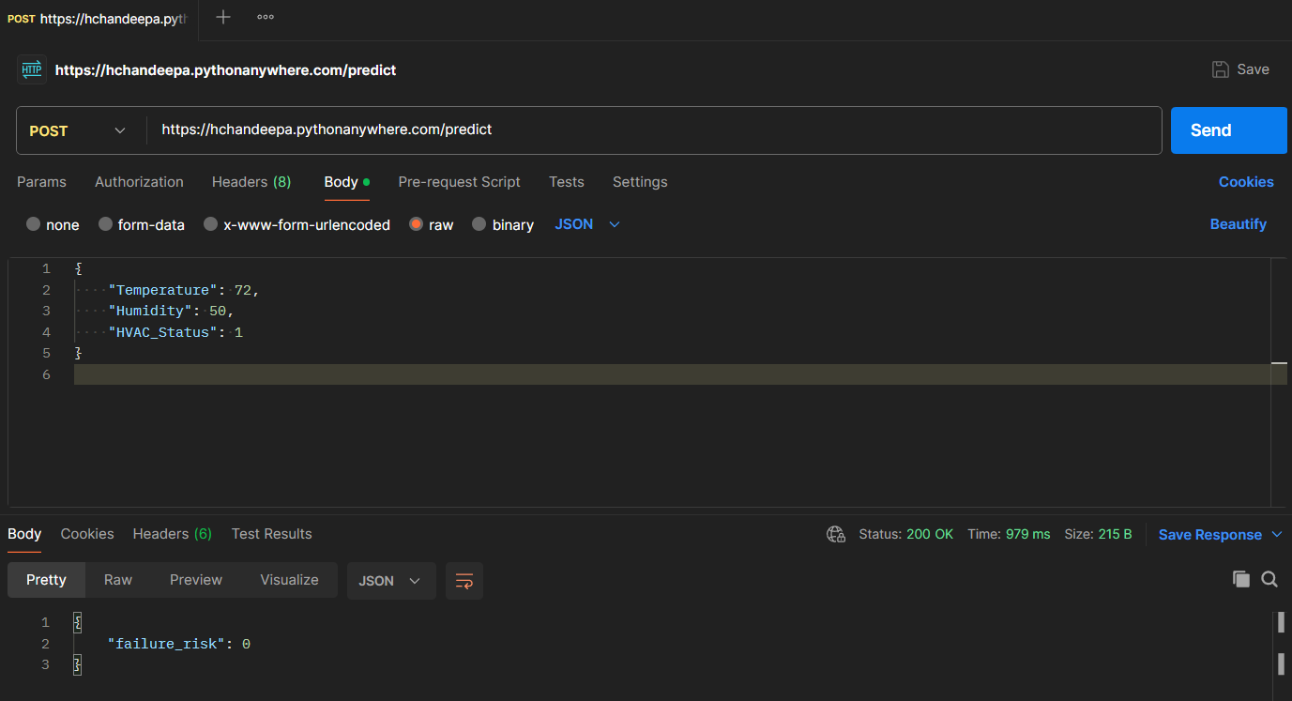

# **Connecting to IoT**

The Flask API can be integrated with IoT devices to receive real-time data for making predictions. For example, a sample code snippet for sending data from an IoT device might look like this:

import requests

# Sample IoT data

data = {

"Temperature": 72,

"Humidity": 50,

"HVAC_Status": 1

}

response = requests.post('https://hchandeepa.pythonanywhere.com/predict', json=data)

print(response.json())

This connection allows for immediate prediction based on live data, facilitating proactive maintenance actions.

# **Next**

* Test the API with actual IoT data to ensure robustness and accuracy.
* Implement additional features such as data logging and user authentication for enhanced security.
* Monitor the API's performance and make necessary adjustments to improve efficiency.